PROJECT TITLE

College Name:United College of Arts and Science College Code:

TEAM ID:NM2025TMID27725



TEAM MEMBERS: 4



**Team LeaderName:DIVYADHARSHINI S**

**Email:** dividivyadharshini8@gmail.com

**Team Member1:DINESH KUMAR S**

**Email:dineshkumar090105@gnail.com**

**Team Member:EBINEZAR S**

**Email:ebiebinezar00@gmai.com**

**Team Member:GOKUL S**

**Email:gokulgokul2720@gmail.com**

# 1.INTRODUCTION

## 1.1ProjectOverview

TheLease ManagementSystem is aSalesforce-based application designed to streamline the processes associated with leasing real estate properties. It handles tenant management, lease

contracts, payments, and communication with automation features such as flows, approval processes, and email alerts.

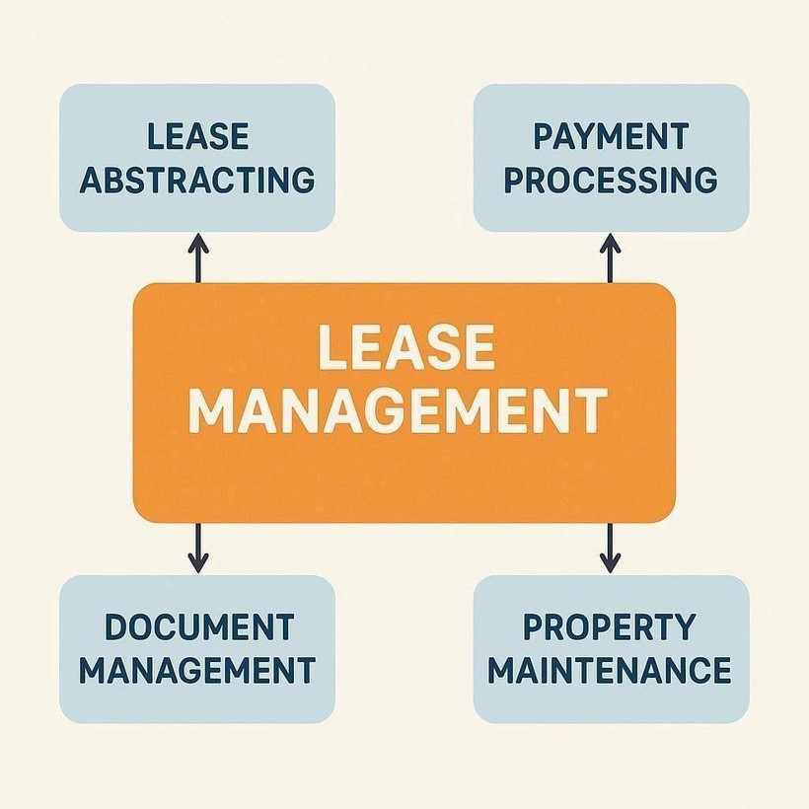

## 1.2 Purpose

The main objective of the project is to enable organizations to efficiently manage properties,

tenants, and lease-related activities. It reduces manual intervention, improves accuracy, and ensures better compliance and communication.

# DEVELOPMENT PHASE

CreatingDeveloper Account:

By using this URL [- https://www.salesforce.com/form/developer-signup/?d=pb](https://www.salesforce.com/form/developer-signup/?d=pb)

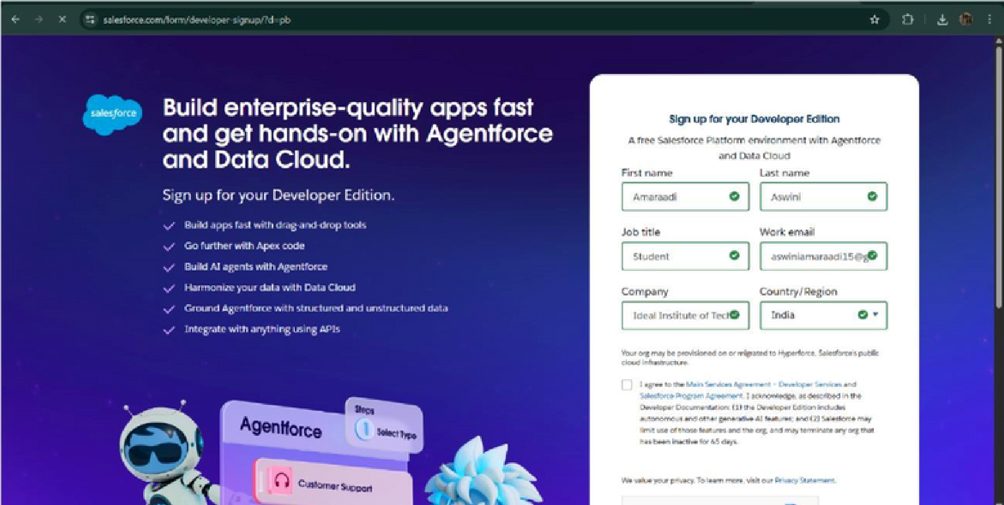

* Created objects: Property, Tenant, Lease,

Payment

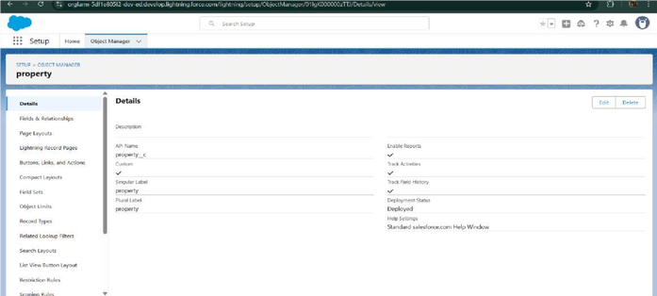

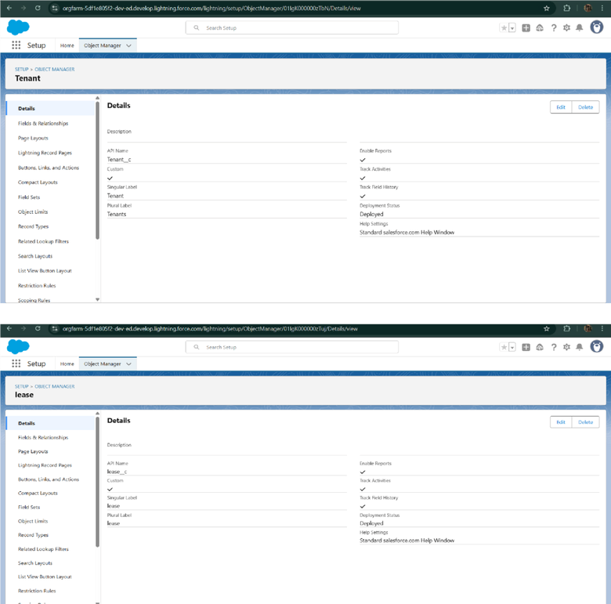

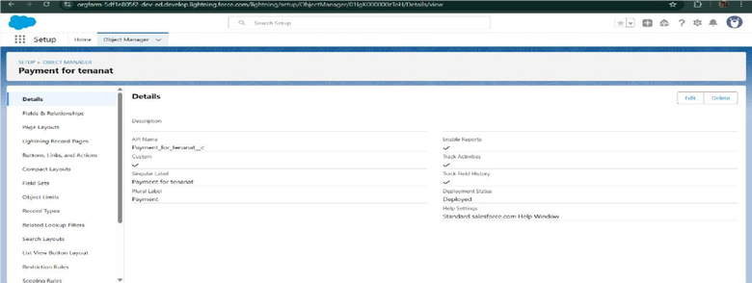

* Configured fields and relationships

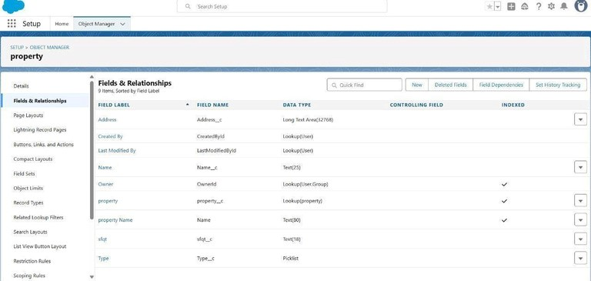

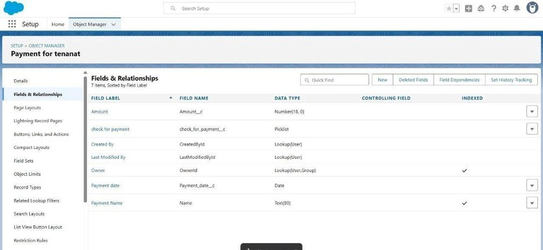

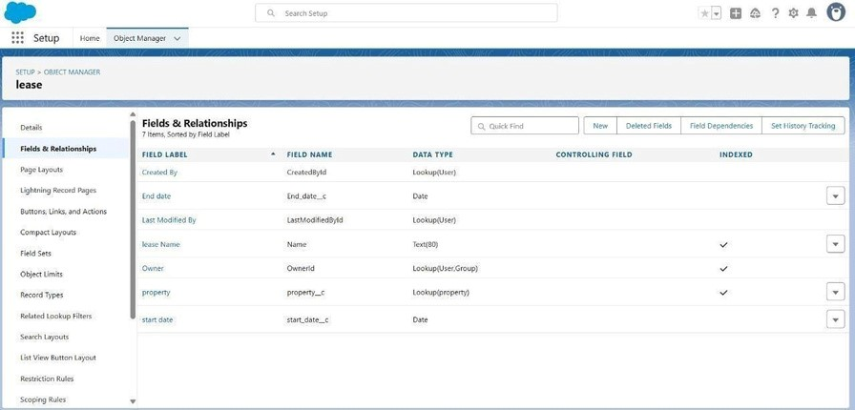

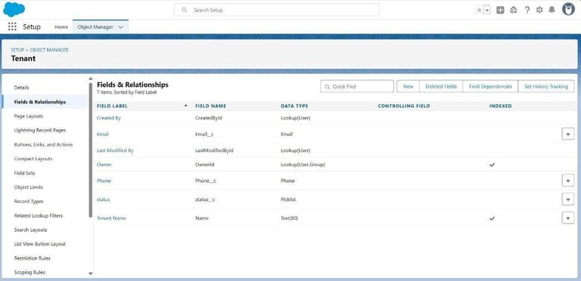

* Developed Lightning App with relevant tabs

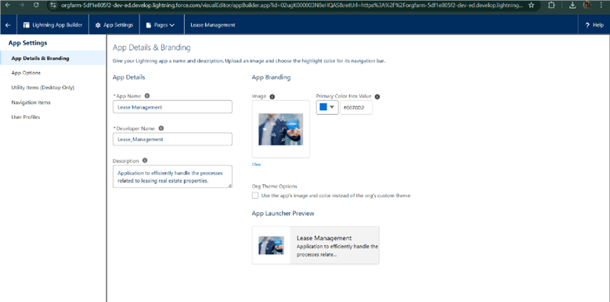

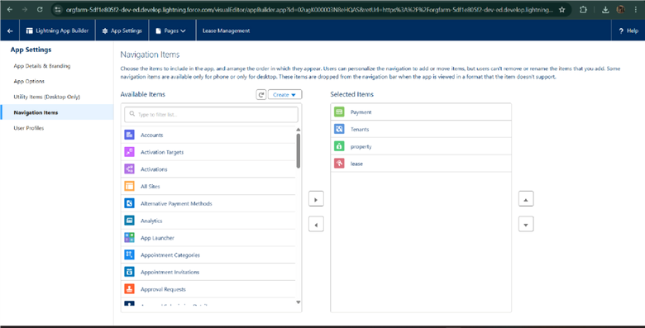

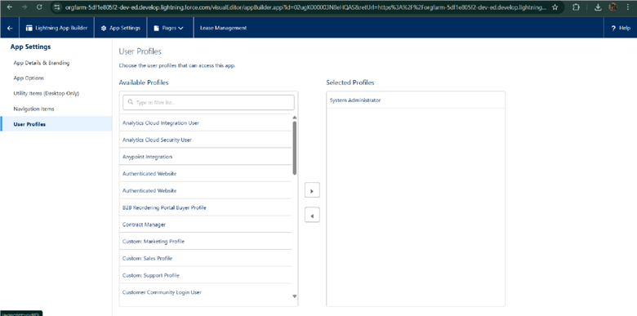

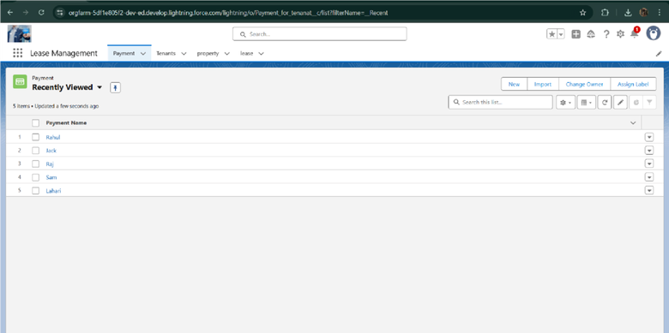

* Implemented Flows for monthly rent and payment

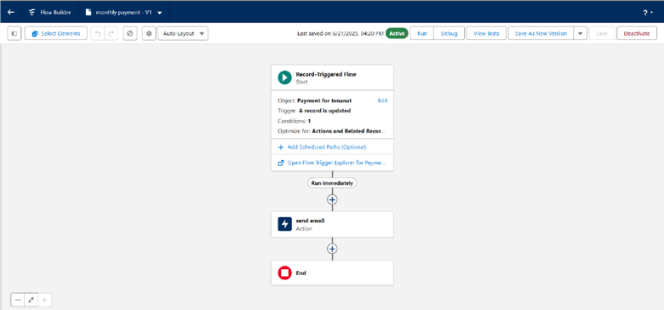

success

* To create a validation rule to a Lease

Object

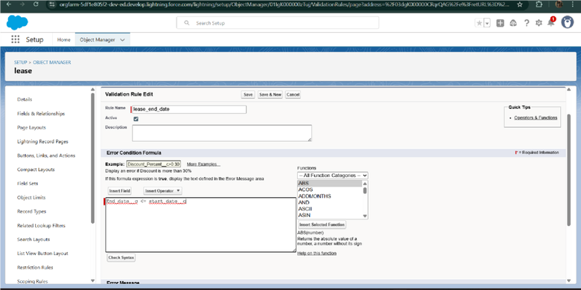

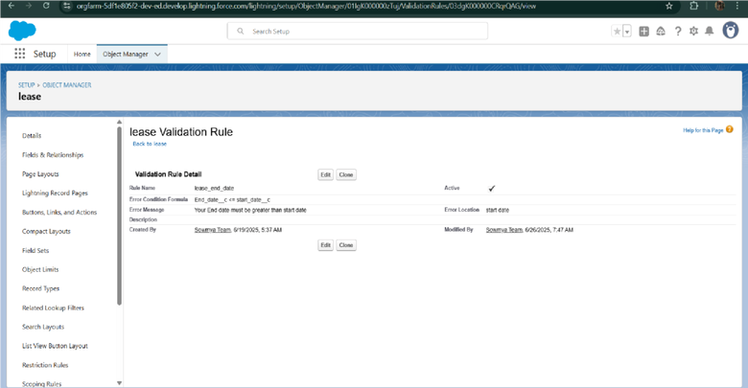

* Added Apex trigger to restrict multiple tenants per property

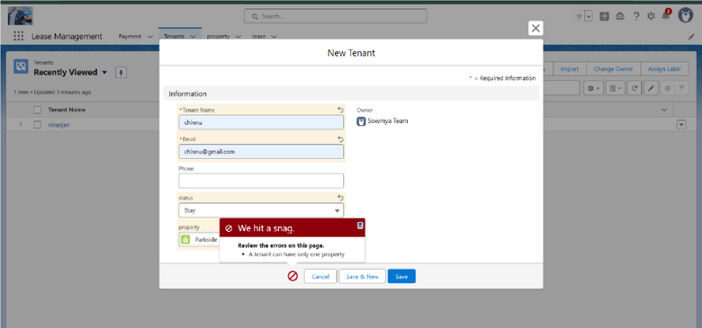

* Scheduled monthly reminder emails using Apex class

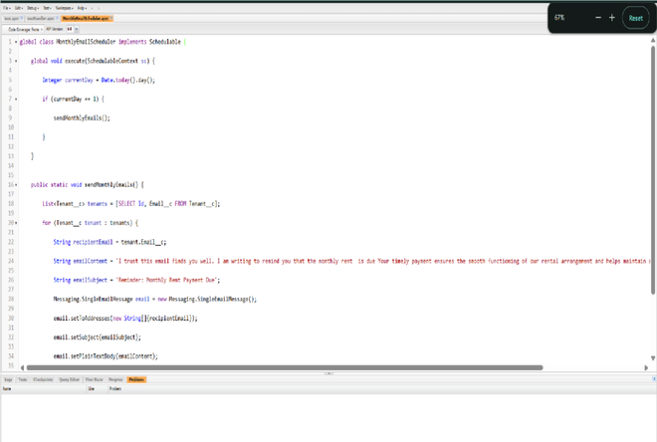

* Built and tested email templates for leave request, approval, rejection, payment, and reminders

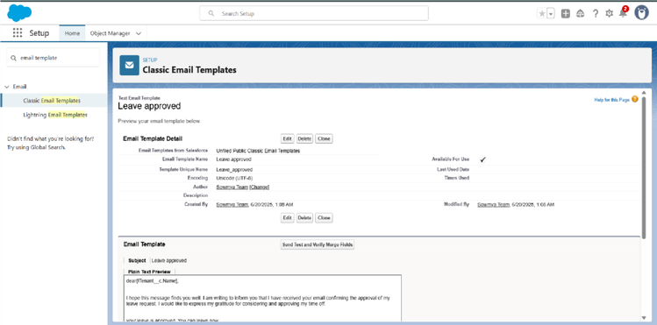

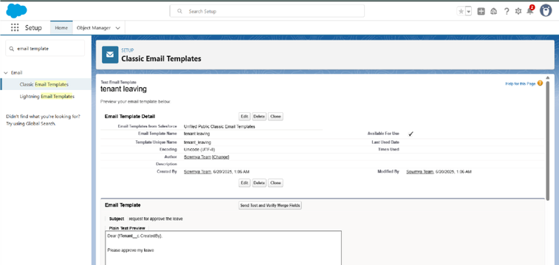

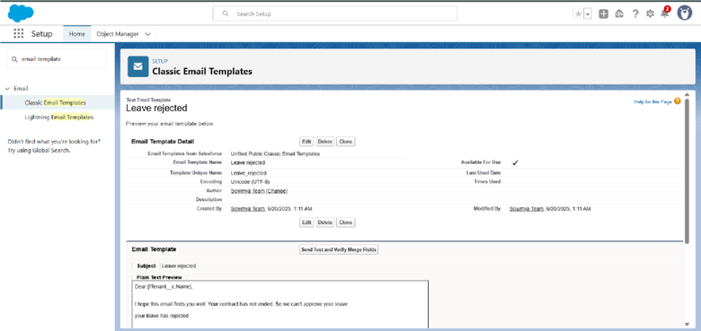

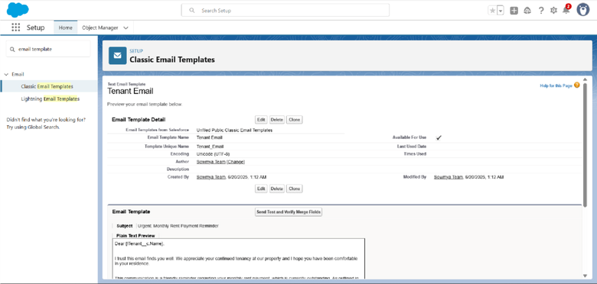

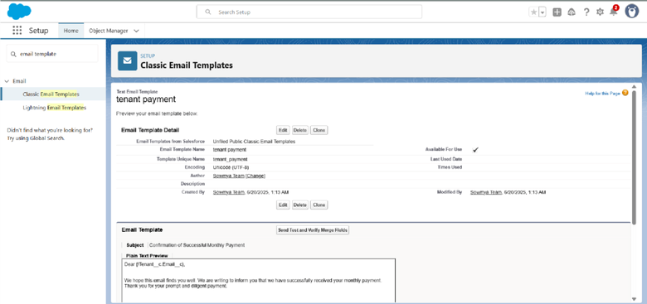

* Approval Process creation For Tenant Leaving:

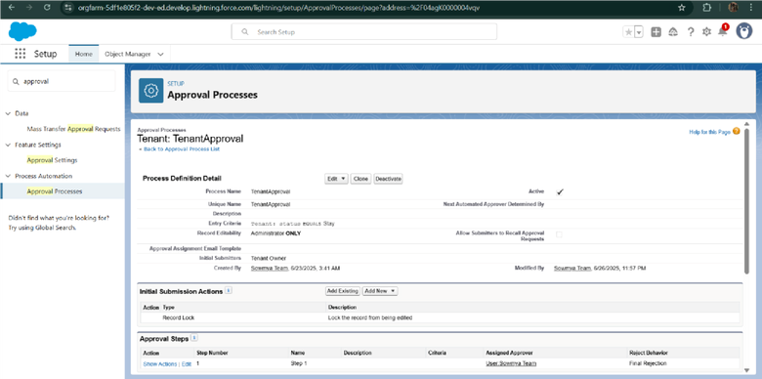

For Check for Vacant:

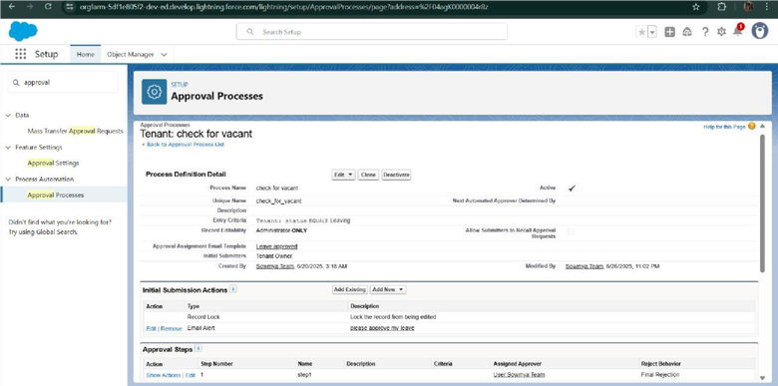

* Apex Trigger

Create an Apex

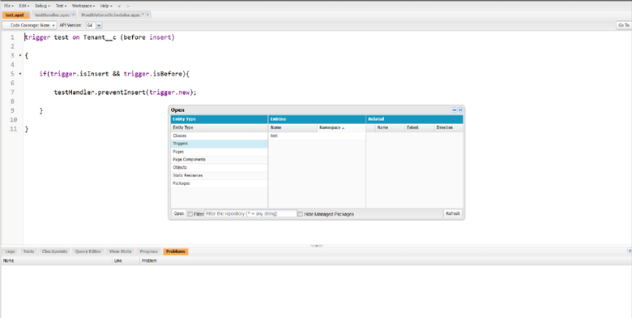

Trigger

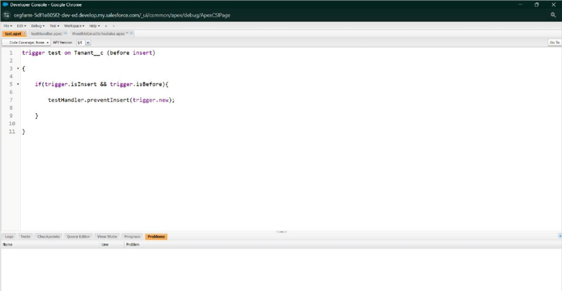

Create an Apex Handler class

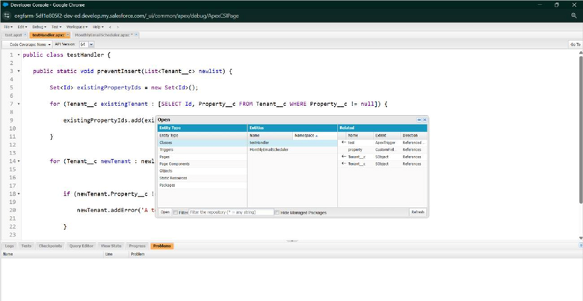

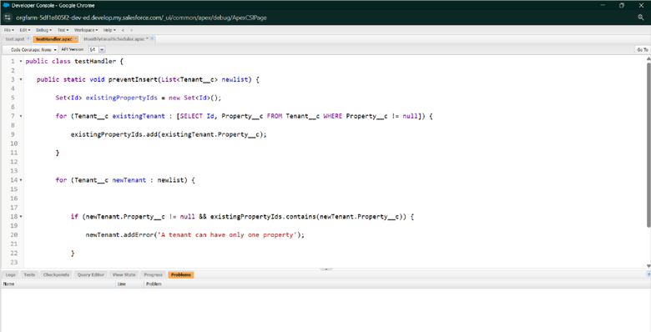

* FLOW

S

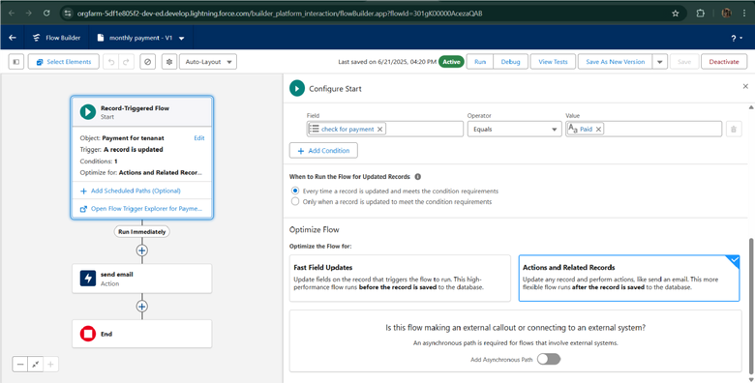

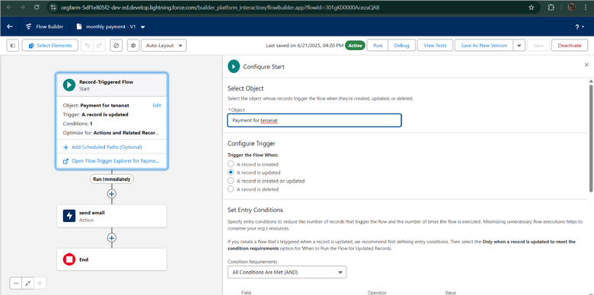

* Schedule class: Create an Apex

Class

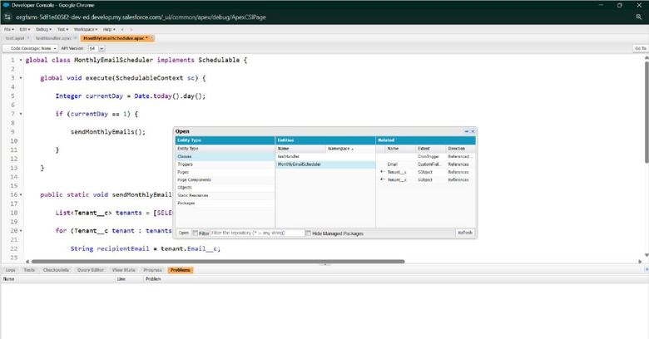

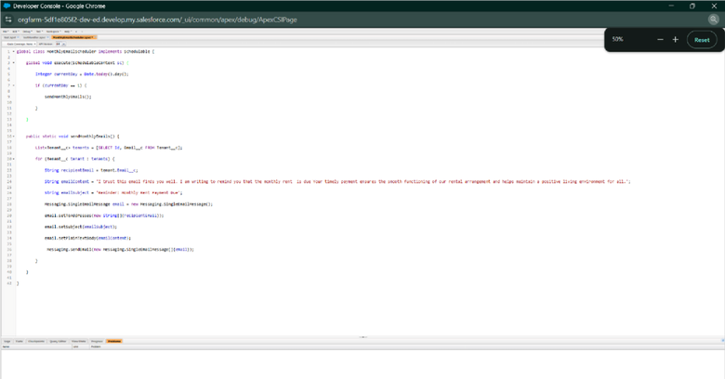

Schedule Apex class

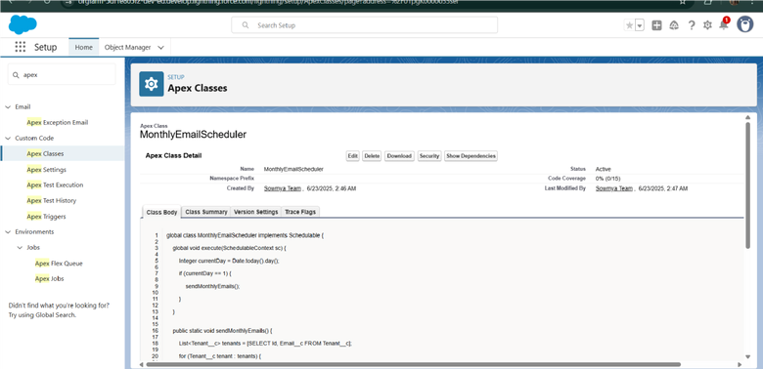

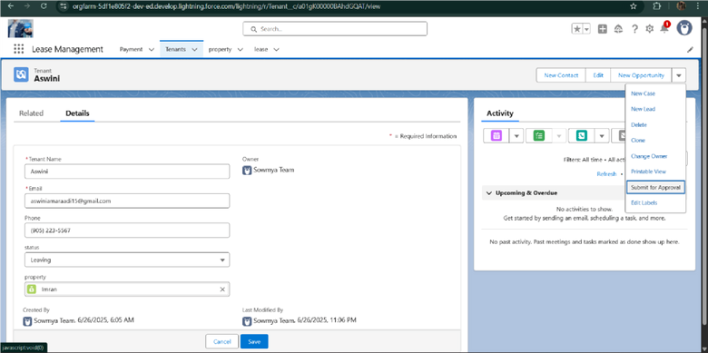

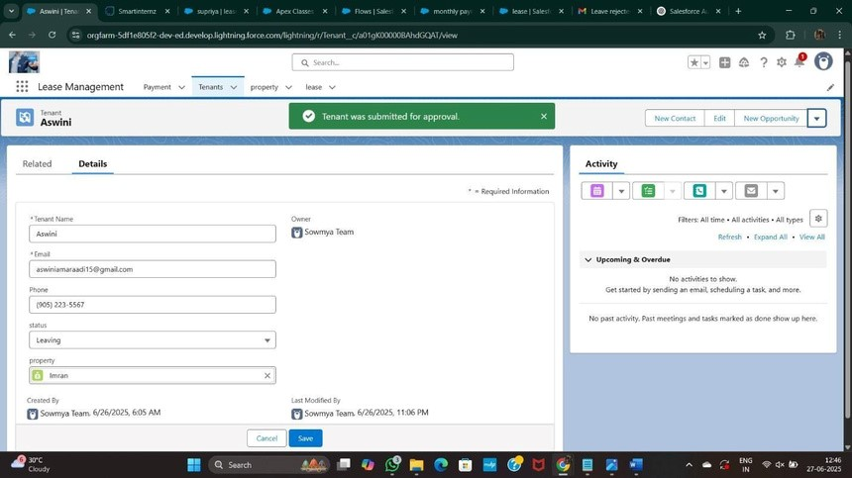



# FUNCTIONAL AND PERFORMANCE TESTING

## Performance Testing

* Triggervalidationbyentering duplicate tenant-property records
* 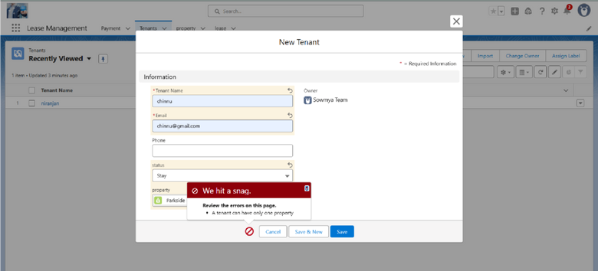Validation Rule

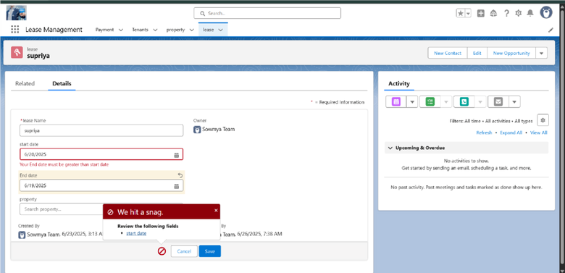

checking

* 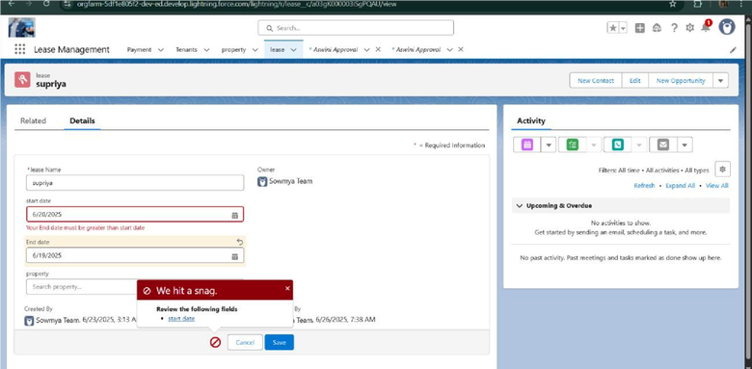Test flows on payment

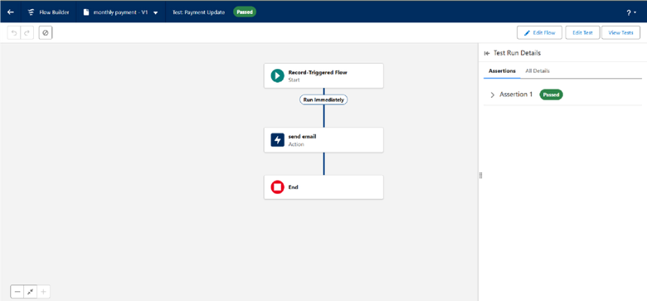

update

* Approval process validated through email alerts and status updates

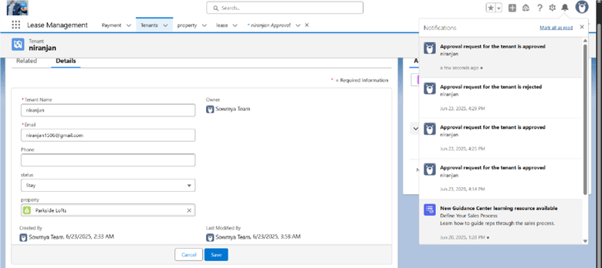

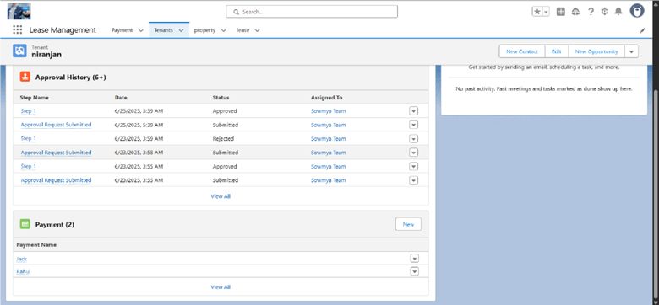



## RESULTSOutput Screenshots

* Tabs for Property, Tenant, Lease,

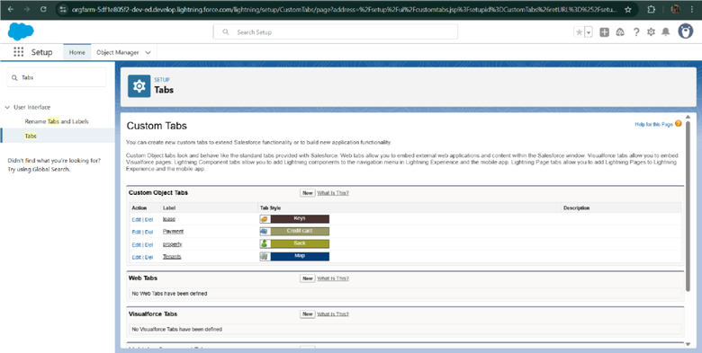

Payment

* Email alerts

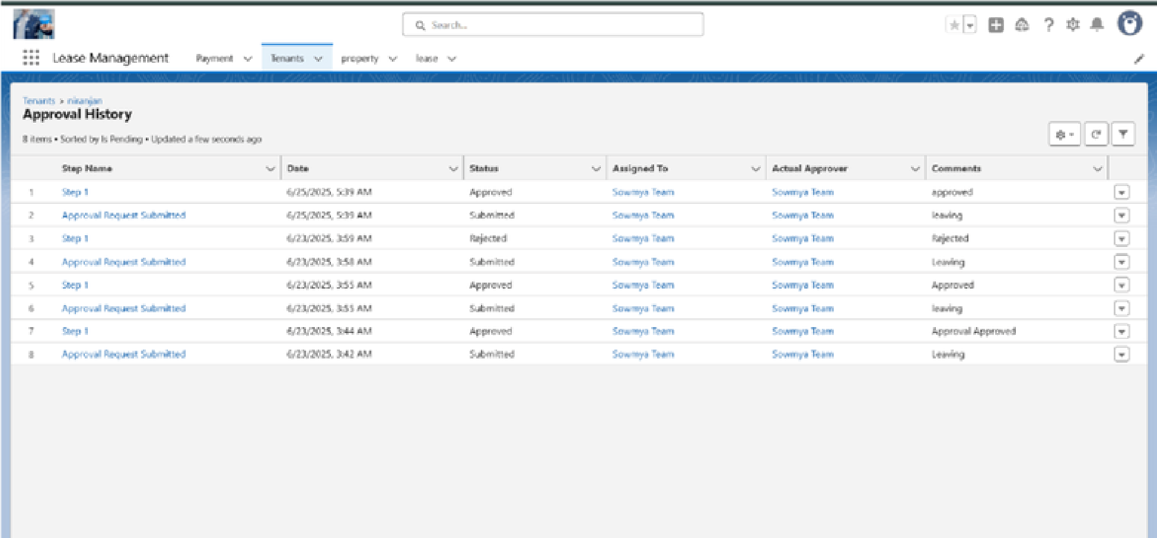

* Request for approve the leave

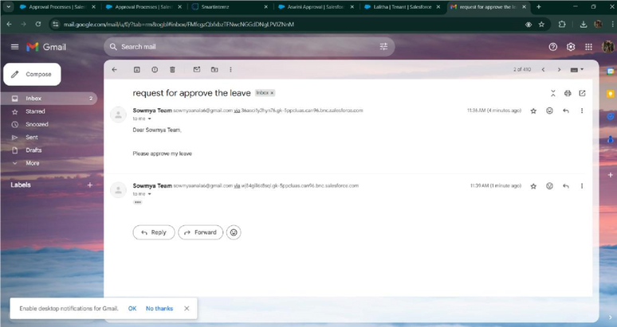

* Leave

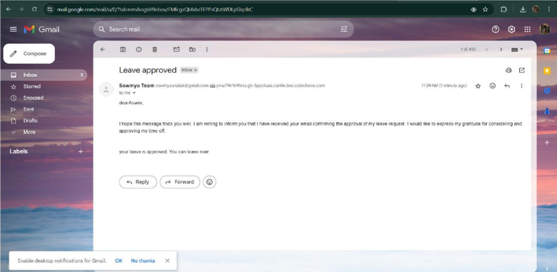

approved

* Leave rejected

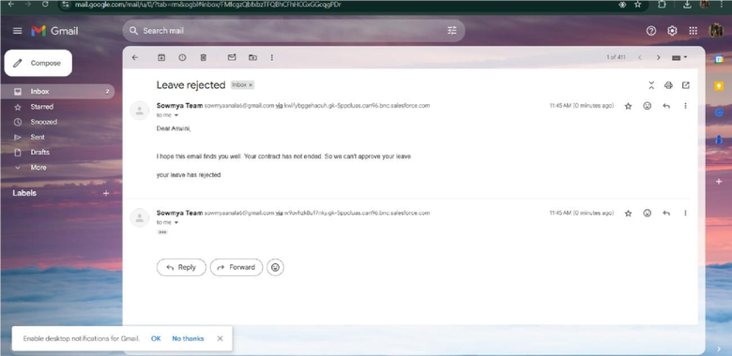

* Flow 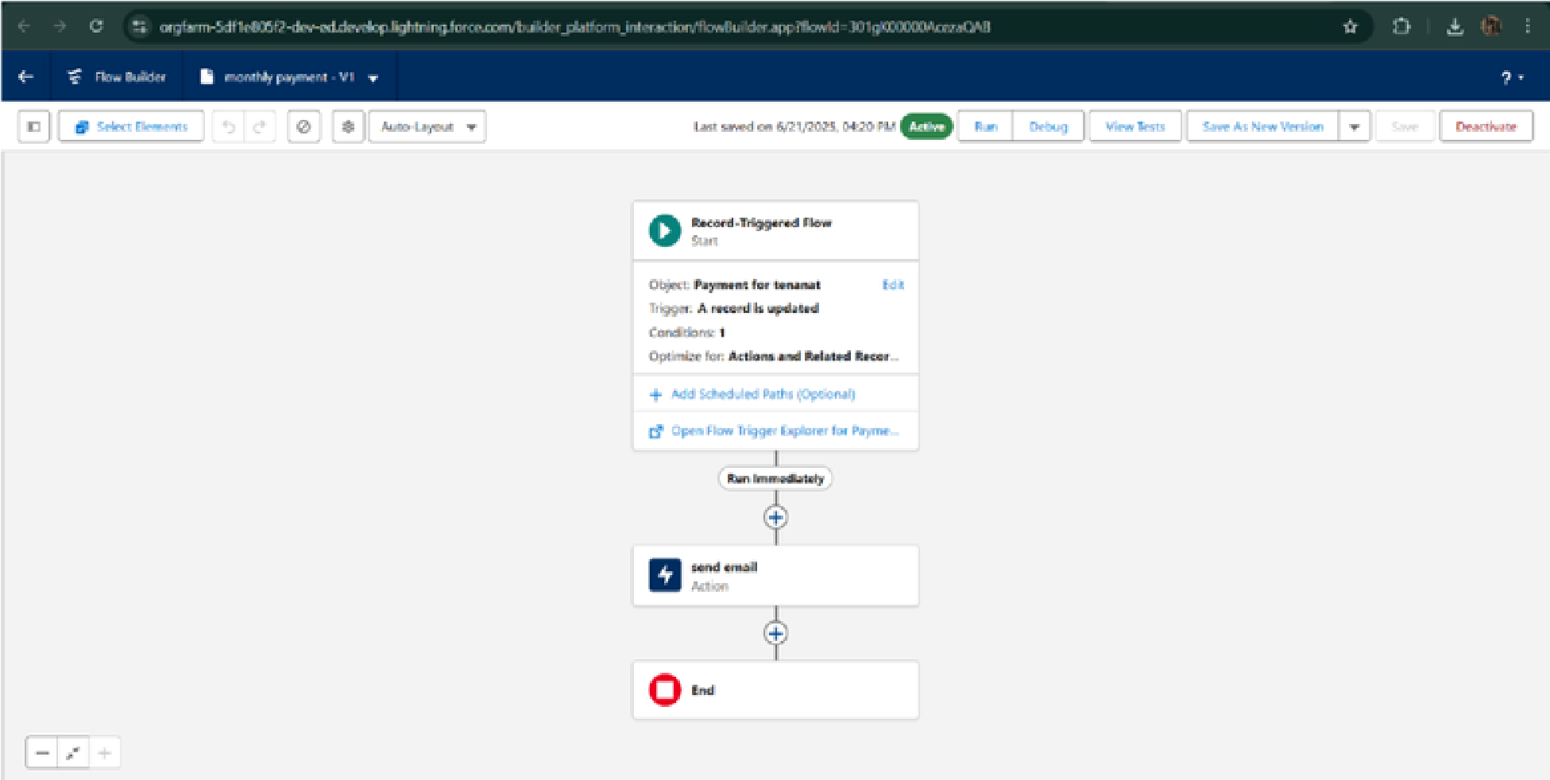runs
* Trigger error messages

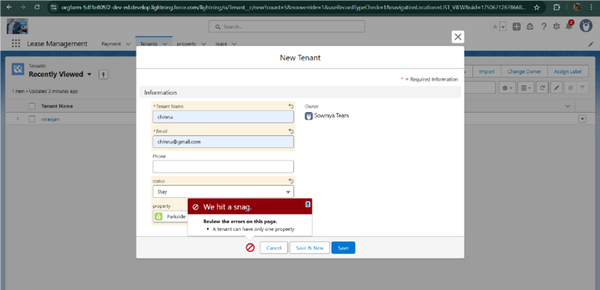

* Approval process notifications

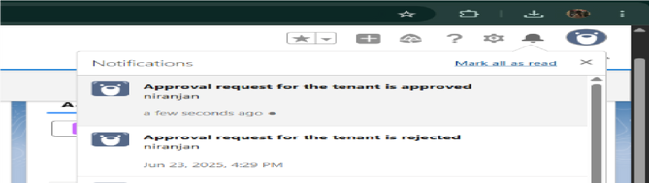



ADVANTAGES &

DISADVANTAGES.



# CONCLUSION

TheLease Management System successfully streamlines the operations of leasing through a structured, automatedSalesforce application. It improves efficiency, communication, and data accuracy for both admins and tenants.



## APPENDI

X ● Source Code: Provided in Apex Classes and

Triggers Test.apxt: trigger teston Tenant__c (before insert) { if (trigger.isInsert && trigger.isBefore){ testHandler.preventInsert(trigger.new);

} } testHandler.apxc:



public class

testHandler { public

static void

preventInsert(List<

Tenant__c> newlist)

Set<Id>

{ existingPropertyId s = new Set<Id>()

for (Tenant__c existingTenant : [SELECT Id, Property__c FROM WHERE Property__c != null]){

Tenant__c existingPropertyIds.add(existingTenant.Property_

_c;

} for (Tenant__c newTenant

: newlist) {

if (newTenant.Property__c != null

existingPropertyIds.contains(newTenant.Property__c)) {newTenant.addError('A

&&

tenant can have only one property');

} }

}

}

MothlyEmailScheduler.apxc:

global class MonthlyEmailScheduler implements Schedulable

{ global void execute(SchedulableContext sc) { Integer currentDay = Date.today().day(); if (currentDay ==

1) { sendMonthlyEmails();

}

} public static void sendMonthlyEmails() { List<Tenant__c> tenants = [SELECT Id, Email__c

FROM

Tenant__c]; for (Tenant__c tenant :String recipientEmail = tenant.Email__c;

tenants) {that the monthly rent is due Your timely payment ensures the smooth functioning of String emailContent = 'I trust this email finds you well. I am writing to remindyou

our

rental arrangement and helps maintain a positive living environment for all.';String emailSubject = 'Reminder: Monthly Rent Payment

Due';

Messaging.SingleEmailMessage email = new Messaging.SingleEmailMessage(); email.setToAddresses(new String[]{recipientEmail}); email.setSubject(emailSubject);

email.setPlainTextBody(emailContent);Messaging.sendEmail(new Messaging.SingleEmailMessage[]

} {email});

}

}